**Section 8.1 - Euler's Method. Cont.**

**Contents**

* Why is it often necessary to use graphical and numerical techniques?

**Why is it often necessary to use graphical and numerical techniques?**

Here is an example of an ODE which MATLAB claims to solve explicitly, but the solution is very complicated. The initial value problem is

$$y'=y^2+t^2, \quad y(0)=1.$$

Here is MATLAB's "exact solution."

y = dsolve('Dy = y^2 + t^2, y(0)=1', 't'); pretty(y)

Warning: Explicit solution could not be found; implicit solution returned.

Warning: The solutions are parametrized by the symbols:

z = solve([limit((4*t*gamma(3/4)*besselK(-3/4, (t^2*I)/2)*I -

2^(1/2)*4^(1/4)*C6*PI^(3/2)*t*besselI(-3/4, (t^2*I)/2)*I)/(4*gamma(3/4)*besselK(1/4,

(t^2*I)/2) + 2^(1/2)*4^(1/4)*C6*PI^(3/2)*besselI(1/4, (t^2*I)/2)), t = 0) = 1], C6,

VectorFormat = TRUE)

1/2 1/4 3/2

4 t gamma(3/4) besselk(-3/4, #1) i - 2 4 pi t z besseli(-3/4, #1) i

----------------------------------------------------------------------------

1/2 1/4 3/2

4 gamma(3/4) besselk(1/4, #1) + 2 4 pi z besseli(1/4, #1)

where

2

t i

#1 = ----

2

The solution is very complicated and involves $z$, which is the solution of a very complicated equation. Also, it gives me an absurd plot:

ezplot(y)

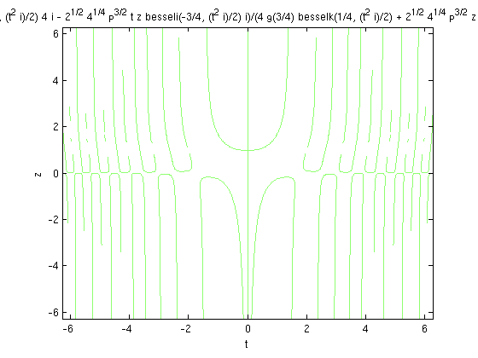

There is a discussion of this example and how to solve it using MuPad on pp;. 72-74 of *Differential Equations with MATLAB*.

We can solve it exactly using Maple, with the command:

dsolve({diff(y(t), t) = y(t)^2+t^2, y(0) = 1}, y(t))

The solution is:

syms t

y = -t*(-(gamma(3/4)^2-pi)/gamma(3/4)^2*besselj(-3/4,1/2*t^2)+...

bessely(-3/4,1/2*t^2))/(-(gamma(3/4)^2-pi)/gamma(3/4)^2*besselj(1/4,1/2*t^2)...

+bessely(1/4,1/2*t^2));

To get a better idea of what the solution is like, we can view it graphically. One method is to plot the solution.

ezplot(y,[0,0.8])

xlabel 't', ylabel 'y'

title 'Solution of dy/dt = y^2 + t^2'

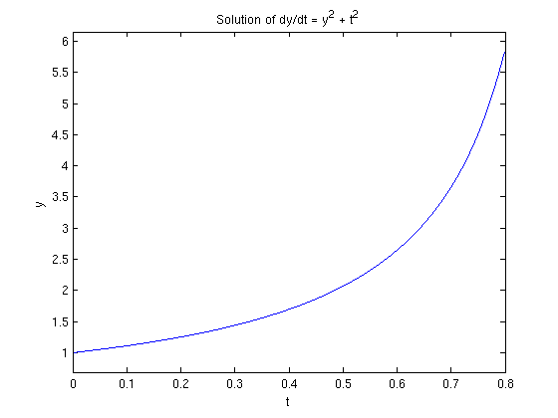

Another method is to look at the direction field using the **quiver** command.

[T,Y] = meshgrid(-3:0.2:3,-3:0.2:3);

S = T.^2 + Y.^2;

L = sqrt(1 + S.^2);

quiver(T, Y, 1./L, S./L, 0.5), axis tight

xlabel 't', ylabel 'y'

title 'Direction field for dy/dt = y^2 + t^2'

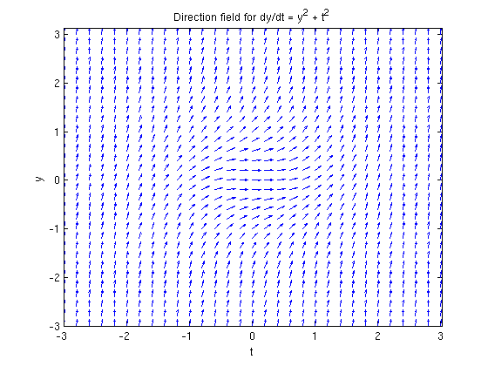

A third method is to solve numerically and plot the resulting numerical solution. Here we do that using **ode45**.

f = @(t,y) y^2 + t^2;

ode45(f,[0,0.8],1)

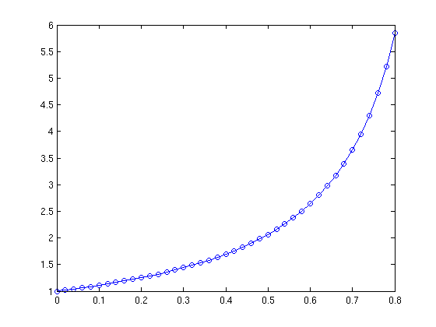

Note that this plot looks the same as what we found when we plotted the explicit solution.

Here's another example where MATLAB finds a very complicated solution.

$$y' = y^2 + t, \quad y(0)=0.$$

y = dsolve('Dy = y^2 + t, y(0) = 0','t')

y =

(airyBi(-t, 1) + 3^(1/2)*airyAi(-t, 1))/(airyBi(-t, 0) + 3^(1/2)*airyAi(-t, 0))

Here's the direction field.

[T,Y] = meshgrid(-3:0.2:3,-3:0.2:3);

S = T + Y.^2;

L = sqrt(1 + S.^2);

quiver(T, Y, 1./L, S./L, 0.5), axis tight

xlabel 't', ylabel 'y'

title 'Direction field for dy/dt = y^2 + t'

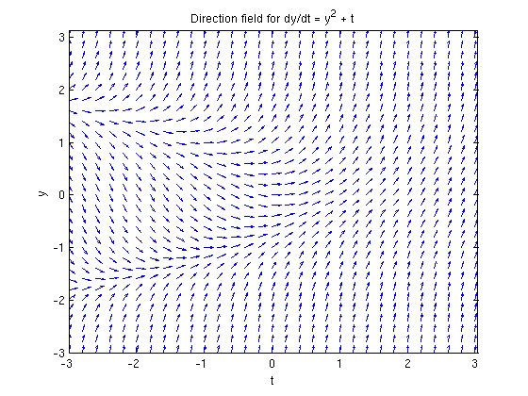

If we attempt to plot the exact solution, we run into a problem. MATLAB doesn't seem to know what **airyAi** and **airyBi** are. Here's a way around that. These functions come from MuPad and haven't been converted to MATLAB notation. (This example is discussed on pp. 61-63 of *Differential Equations with MATLAB*.)

tvals = 0:0.01:2;

plot(tvals,double(subs(y,'t',tvals)))

xlabel 't', ylabel 'y'

title 'Exact solution'

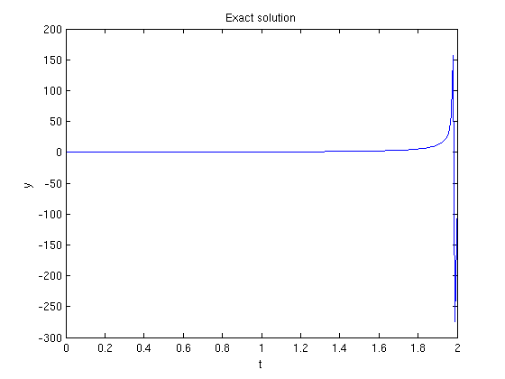

Can this be correct?

Alternatively we can plot the numerical solution obtained with **ode45**.

f = @(t,y) y^2 + t;

[t,ya] = ode45(f,[0,2],0);

plot(t,ya)

Warning: Failure at t=1.986314e+00. Unable to meet integration tolerances without

reducing the step size below the smallest value allowed (3.552714e-15) at time t.

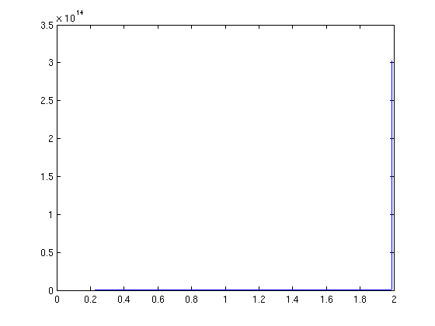

Can this be correct?

Here is a problem MATLAB can't solve exactly.

$$y' = \mbox{--}\,t^2 y^3 + \cos(t), \quad y(0) = 0.$$

There is no choice but to use graphical and numerical techniques to analyze this equation. Here is the direction field.

[T,Y] = meshgrid(-3:0.2:3,-3:0.2:3);

S = -T.^2*Y.^3 + cos(T);

L = sqrt(1 + S.^2);

quiver(T, Y, 1./L, S./L, 0.5), axis tight

xlabel 't', ylabel 'y'

title 'Direction field for dy/dt = -t^2 y^3 + cos(t)'

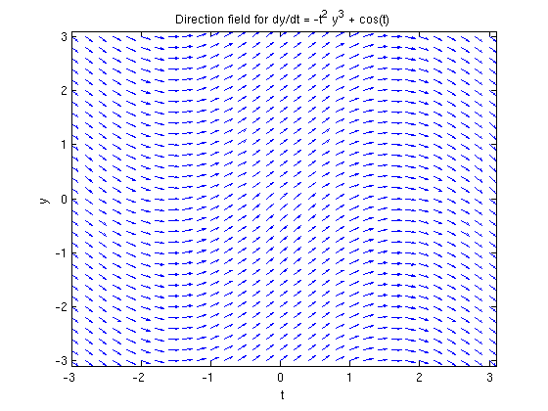

Here is a plot of the numerical solution obtained with **ode45**.

f = @(t,y) -t^2*y^3 + cos(t);

[t,ya] = ode45(f,[0:100],0);

plot(t,ya)

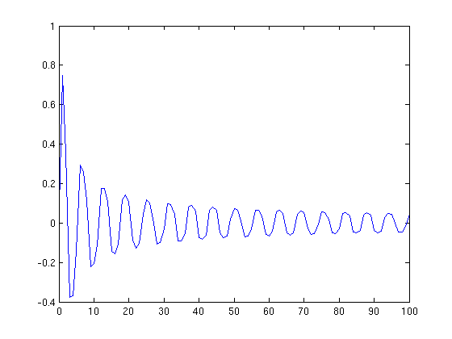

From this we see that the solution appears to tend slowly towards 0 in an oscillating manner as x gets very large.

Published with MATLAB® 7.13